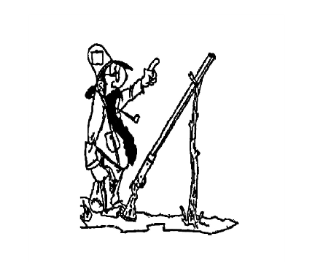
Portersville Muddy Creek V.F.D.
John Saunders Memorial
Fun Shoot
WHEN:
August 29th 2020
Registration starts at 8:30 a.m. Shooting starts at 9:30
WHERE:

Castlewood Rod & Gun Club
2964 Shaffer Rd, New Castle, PA 16107

Try your shot gunning skills in an open invitation sporting clays event including 100 targets. A lunch will be provided and prizes awarded to top five participants (HOA Team and HOA individual). A gun raffle will be held for all participants present on the day of the shoot.

Cost:
$50.00 per participant if received before August 1st
$60.00 per participant after August 22nd
$70.00 per participant on the day of the shoot
Includes:
100 targets
Lunch
Raffle ticket for Shotgun drawing

There will be Door Prizes, gun raffle tickets and much more please join us for the fun and come out to support
Portersville Muddy Creek V.F.D

Scores will be based on 5 man squads. The highest 4 scores will be scored together.

For more information please contact Portersville Muddy Creek Volunteer Fire dept. at 724-368-4444 or Austin Beachem at 724-679-1560

To join us please fill out and return this form with remittance.
__________________________________________________________________________________________

Captains Name_____________________ Phone Number__________________

Name_____________________________ Name_________________________

Name_____________________________ Name_________________________

Total Amount Enclosed:__________________

Please make checks payable to Portersville Muddy Creek V.F.D.
Mailing address - Portersville Muddy Creek VFD ◦ P.O. Box 248 ◦ Portersville, PA 16051

